CC Algebra 2 Name _________________________________________________

F-IF Warming and Cooling (Interpreting Functions from Graphs) Date __________________________

*Illustrative Mathematics*

The figure below shows the graph of *T*, the temperature (in degrees Fahrenheit) over one particular

20-hour period in Santa Elena as a function of time, *t*.

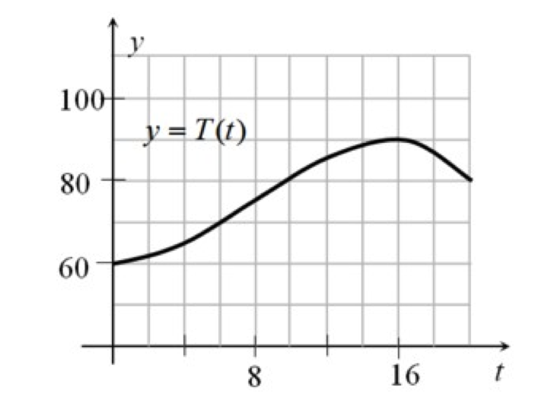

time (*t*) in hours

Temperature (T)

in degrees Fahrenheit

1. Estimate  = ________________ (be sure to label your answer with the appropriate unit of measure)

2. If  corresponds to midnight, interpret what we mean by  in words. Use complete sentences.

3. According to the graph, estimate the highest temperature during this period of time. Explain your answer.

4. For what time interval was the temperature decreasing? Again, be sure to use appropriate labels.

5. If Anya wants to go for a two-hour hike and return before the temperature goes over 80 degrees, when should she leave? Justify your answer; use the graph and math vocabulary.