Algebra 2 Name ______________________________________________

HW - Graphical Analysis Date ________________________

The graph of a cubic function is shown.
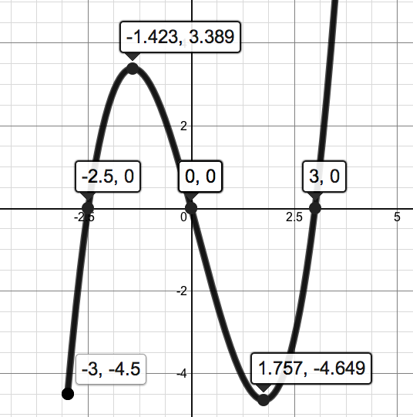

Answer each, using the appropriate notation when requested. You may round values to the nearest tenth.

1. Domain: ____________________ (interval notation)

2. Range: ______________________ (interval notation)

3. Local Maximum: _________________ (ordered pair)

4. Local Minimum: _________________ (ordered pair)

5. For the interval (-1, 1), is the function increasing , decreasing or neither ?
(circle your choice)

Don’t forget to complete the book page of Homework, too: Page 22, #23 - 31 odd. Show all work and circle your final answer.

