Things to know:
- Simple Probabilities
- Compound Probabilities (intersections, unions and complements)
- Conditional Probabilities (given B what is the probability of A)
- Independent and Dependent Events
- Permutations and Combinations

What are all the formulas you need to know for this test??

1. Write a scenario based on the survey results shown below. Then write 3 probability problems based on your scenario.
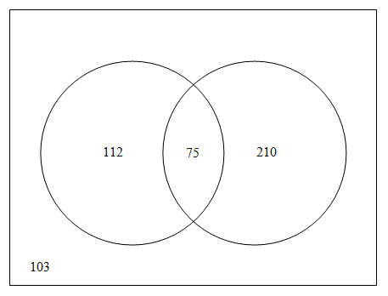

2. At Bayside High School 42% of their students participate in a sport after school, 27% of their students participate in an after school club, and 15% of students participate in both a club and sport after school. The principal, Mr. Belding, would like determine how involved their students are in the after school activities. What is the probability that a randomly selected Bayside student will participate in either a club or sport after school?

3. Examine the spinner below. What is the probability that you land on pink on your first spin and a number greater than 2 on the second spin?

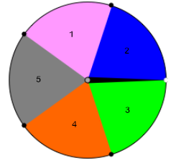

4. Mrs. Kelley gathered data about the hand preferences of her students. She recorded the data in the table below:

 | Right-handed | Left-handed | Total
Male | 48 | 14 | 62
Female | 64 | 10 | 74
Total | 112 | 24 | 136

- If a student from Mrs. Kelley’s classes is selected at random, what is the probability that the student is a female?

- If a student from Mrs. Kelley’s classes is selected at random, what is the probability that the student is left-handed?

- If a student from Mrs. Kelley’s classes is selected at random, what is the probability that the student is a female who is right-handed?

- If a male student from Mrs. Kelley’s classes is randomly selected, what is the probability that he is right-handed?

- If a left-handed student from Mrs. Kelley’s classes is randomly selected, what is the probability that the student is a female?

- Are the events “male” and “left-handed” independent events? Support your answer using appropriate probability calculations.
5. Examine the following events:
Event A: “I get the flu.”
Event B: “I do not wear a winter coat”

If you determine that the P(A) = P(A|B), explain what this conclusion means in the context of the problem.

6. The following cards have been placed in a bag:

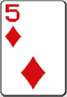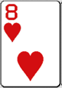
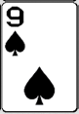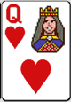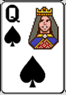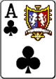

You select a card, do not replace the card in the bag, and then select a second card. If Event A is “draw a five on the first draw” and Event B is “draw a heart on the second draw”. Find the probability that both events will occur.

7. Jen and Charlene are members of the school volleyball team. There are 12 members of the team. The coach will be selecting two players at random to serve as team captains. What is the probability that both Jen and Charlene will be selected as captains?

8. Fifteen students are competing in an essay contest. How many different ways can students be selected for a first, second, or third place prize?

9. Jon and Julie create a game. Each player rolls two dice. If the sum is less than 6, than Jon earns a point. If the sum is greater than 6, then Julie earns a point. The first player with 10 points wins the game. Is this game fair? Why or why not?

