**Proving Figures on a Coordinate Plan Practice**

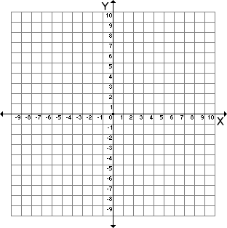1) Triangle DAN has coordinates D(-10,4), A(-4,1), and N(-2,5)

Using coordinate geometry, prove that triangle DAN is a right triangle.

3) The coordinates of the vertices of ΔSUE are S(-2,-4), U(2,-1), and E(8,-9).

Using coordinate geometry, prove that triangle SUE is scalene.

4) The vertices of quadrilateral JOHN are J(-3,1), O(3,3), H(5,7), and N(-1,5).

Use coordinate geometry to prove that JOHN is a parallelogram.

5) Quadrilateral MIKE has vertices M(4,1), I(6,4), K(12,0), and E(10,-3).

Use coordinate geometry to prove that quadrilateral MIKE is a rectangle.



6) The coordinates of the vertices of quadrilateral DIAN are D(0,5), I(3,6), A(4,3), and N(1,2).

Use coordinate geometry to prove that quadrilateral DIAN is a square.

